FOR IMMEDIATE RELEASE
May 14, 2015
Contact: Susan Evans Grove
1+703.997.6706
sevans@sname.org

SNAME Member Professor Jeom Kee Paik Receives
The Royal Institution of Naval Architects William Froude Medal

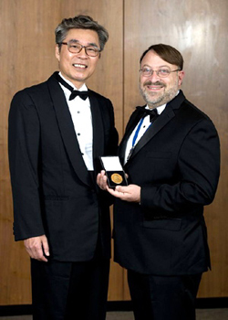ALEXANDRIA, VIRGINIA (USA) - SNAME member Professor Jeom Kee Paik, Professor of Ship and Offshore Structural Mechanics at the Pusan National University, Korea, has received The Royal Institution of Naval Architects (RINA) William Froude Medal, RINA's highest professional honor.

This award makes Professor Paik only the third person to receive both the Froude Medal and SNAME's David W. Taylor Medal, which he received in 2013. The other two recipients of both awards were Douglas Faulkner, who received the Taylor Medal in 1991 and John B. Caldwell, who received the Taylor Medal in 1987.

PHOTO CAPTION: Froude Medal Winner Professor Jeom Paik with current RINA President and past SNAME President Bruce Rosenblatt.

Since the inception of RINA in 1860, the William Froude Medal has been presented to just 27 individuals who have made a conspicuous contribution to naval architecture or shipbuilding and whose service and personal achievements merit special recognition. William Froude was known as the first to formulate reliable laws for the resistance that water offers to ships (such as the hull speed equation) and for predicting their stability.

The David Taylor Medal has been awarded for notable achievement in naval architecture and/or marine engineering since 1936. Taylor is best known for constructing the first experimental towing tank built in the United States in 1896. The David Taylor Model Basin at Carderock, part of the Naval Surface Warfare Center, was built in 1939 and is named after Taylor. Visit www.sname.org/sname/directories/programsresources/awards/davidwtaylormedal for more information about the Taylor Medal.

Professor Paik is a Fellow of SNAME and has served as International Vice President, a member of the Technical & Research Steering Committee, several T&R panels and on the Editorial Board of SNAME's membership magazine (mt).

SNAME offers numerous awards and medals in recognition of professional achievement. For information about SNAME awards programs, visit www.sname.org/awardscommittee/home.

SNAME is an internationally recognized non-profit, technical, professional society of individual members serving the maritime and offshore industries and their suppliers. Founded in 1893, the Society comprises over 6,000 individuals throughout the world. Membership is open to all interested individuals. For membership information, visit www.sname.org.

-0-

SNAME - 99 Canal Center Plaza, Suite 310 - Alexandria, VA 22314 USA

People news release prepared by Home Port Marine Marketing
www.homeportmarine.com

